**Hotel Management System**

**Group 09**

|  |  |
| --- | --- |
| **Index Number** | **Name** |
| TG-1081 | M.D.V.Dias |
| TG-1048 | A.R.M.Geethanga |
| TG-1073 | T.M.K.G.D.L.Thennakoon |
| TG-1069 | H.M.D.Anuruddhika |
| TG-1080 | R.M.S.R.A.Rathnayake |
| TG-1022 | H.L.D.Devindi |
| TG-1039 | K.A.A.D.Jayarathna |

1. **Introduction and Background**

A hotel management system is a piece of software that helps staff members and hotel administrators to efficiently oversee different operations. It offers a single platform for tasks including managing reservations, checking in/out guests, managing room inventory, billing, cleaning, and reporting.

A hotel management system aids in streamlining operations, enhancing the guest experience, and facilitating improved decision-making for hotel managers by automating and integrating various activities. It works as a complete tool to boost productivity, increase revenue, and provide top-notch service in the hospitality sector. Many different services can be seen in a hotel management system and this management system should be prepared so that they can be efficiently provided to the customer and the related services can be provided easily to the hotel staff.

We realized that the system should be adjusted so that the time taken for certain small tasks can be minimized and the customer can be provided with an efficient service.

Also, this system was developed so that the hotel top management bodies can see the customer satisfaction and customer complaints. In this way, the management will be able to quickly identify the problems in the hotel system and solve them very quickly.

**2. Information about the existing systems.**

**Manual Hotel Management System**

A manual hotel management system is the conventional method of running a hotel without the aid of automated or computerized software. In this system, manual processes involving pen and paper or physical record-keeping systems are used to carry out functions including reservation administration, guest check-in/check-out, room assignment, and billing. To manage diverse hotel activities, staff members rely on communication and manual methods. While smaller or less technologically equipped facilities may still use this method, it can be time-consuming, prone to mistakes, and less effective than contemporary computerized hotel management systems.

**Computer Based Hotel Management Systems**

Software programs called computer-based hotel management systems are made to automate and streamline different hotel processes. These systems use technology to handle important operations including bookings, visitor check-ins and check-outs, room inventories, billing, housekeeping, and more. Computer-based hotel management systems increase productivity, accuracy, and overall customer satisfaction by swapping out manual operations with digital ones. They provide centralized platforms that let hotel management to access real-time data, report, and analyze it in order to make wise decisions. Numerous commonly used software programs including Opera PMS, Protel PMS, Amadeus Hospitality, and Guestline are examples of computer-based hotel management systems. For hotels of all sizes, these tools are essential for streamlining operations, improving guest experiences, and boosting income.

* Oracle Hospitality Opera
* Amadeus Hospitality
* Cloudbeds
* RMS Cloud
* Maestro PMS
* Hotelogix
* eZee Absolute

1. **Functionalities of the Application**

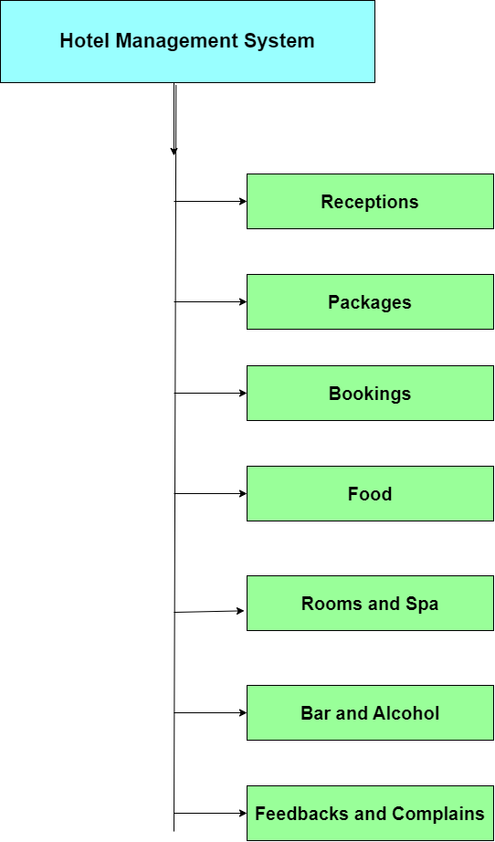

1. **Receptions**

Under this receptions function facilities like customer registration, customer details maintenance, customer details update, customer details search and customer details deletion are provided.

1. **Packages**

Under the packages, various food and drinks are allocated as required for birthdays, weddings and other festive occasions, food is provided according to the number of guests and the cost is calculated and displayed to the customer.

1. **Bookings**

Under this bookings function, the customer can know the details of the hotel and the currently available rooms and reserved rooms.

1. **Food**

Under the food functions, facilities such as adding new food types, searching for existing food types, changing existing food types, and deleting the included food types are provided.

1. **Rooms and Spa**

The rooms and spa function allows you to search for room details and room numbers in the hotel. The customer is also provided with the facility to pay for the reserved rooms

1. **Bar and Alcohol**

Bar and alcohol functions allow customers to order alcoholic and non-alcoholic beverages. This section allows you to order the required drink as required and calculate the cost instantly and display it on the screen.

1. **Feedbacks and Complains**

Feedbacks and complain function allows the customer to enter their ideas and suggestions as well as complaints and new suggestions in the system and only the authorized users. The hotel management or the directors can read the suggestions, comments and complaints.

1. **Flow Charts and Pseudo Codes**

**Receptions ()**

**TG/2021/1069**

**H.M.D.Anuruddhika**

This is the code related to the reception part of the hotel management system. Here we need to enter the customer's name, room number, address, phone number, email, length of stay and the date of entry into the system.. After that it will be stored in a separate file. It is also possible to display information, remove information from the system and update information. This is the reception part of the entire hotel management system.

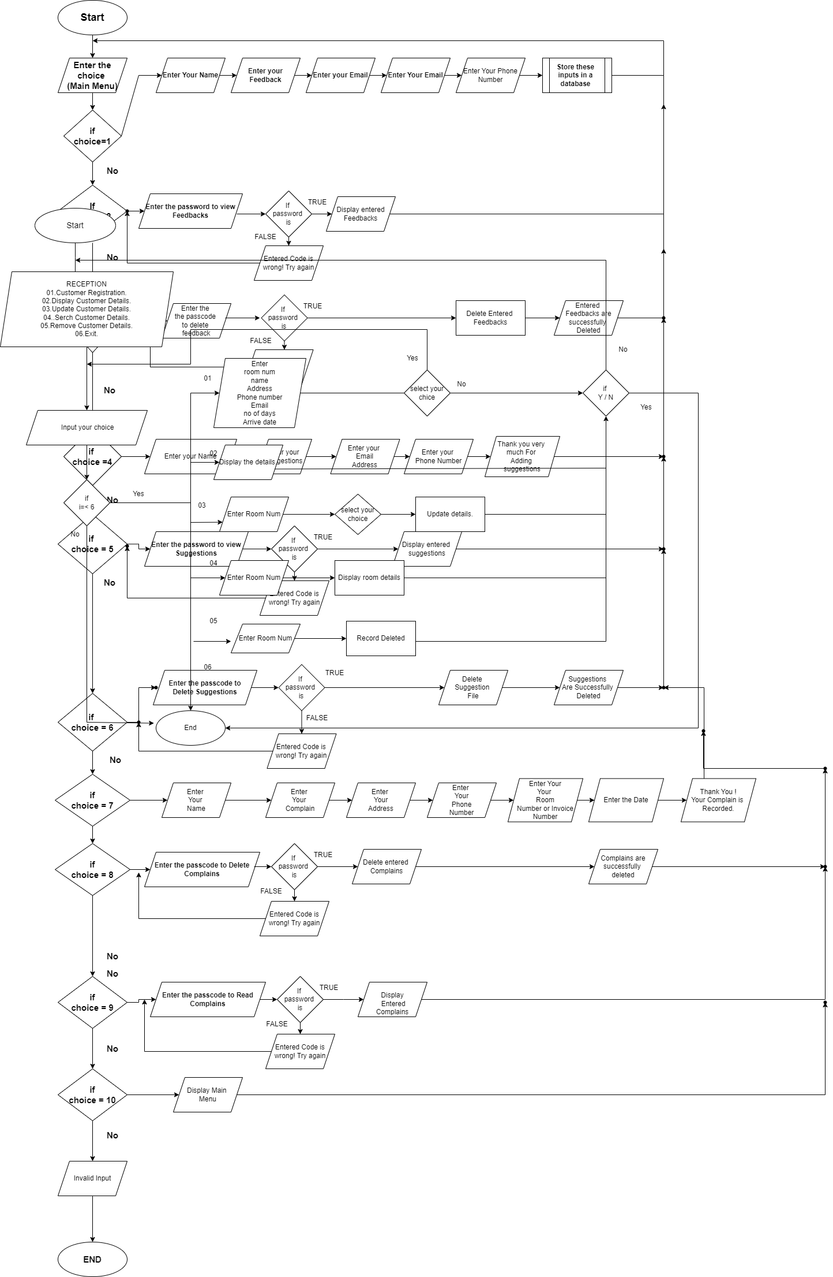

*BEGIN*

*Print menu*

*DECLARE rep, roomNumber, name, address, phonenumber, email, period, arrivaldate,*

*I, choice.*

*INPUT choice*

*Switch(choice)*

*Case 1*

*Insert()*

*Case 2*

*empty()*

*IF emp==0 ? THEN*

*print “The file is empty”*

*switch(rep)*

*case y||Y*

*insert()*

*case n||N*

*reception()*

*ELSE*

*disp()*

*ENDIF*

*Case 3*

*Update()*

*Case 4*

*Search()*

*Case 5*

*Removedetails()*

*Case 6*

*Print”Thank you”*

*END*

**Bookings ()**

**TG/2021/1022**

**H.L.D.Devindi**

This is the code related to the booking part of the hotel management system. Here was switch case then enter your choice you can see display hotel information, Available, Reservation and Exit. Reservation part has calculate the bill of your booking. After that customer details and booking details store the files. This is the booking part of the program.

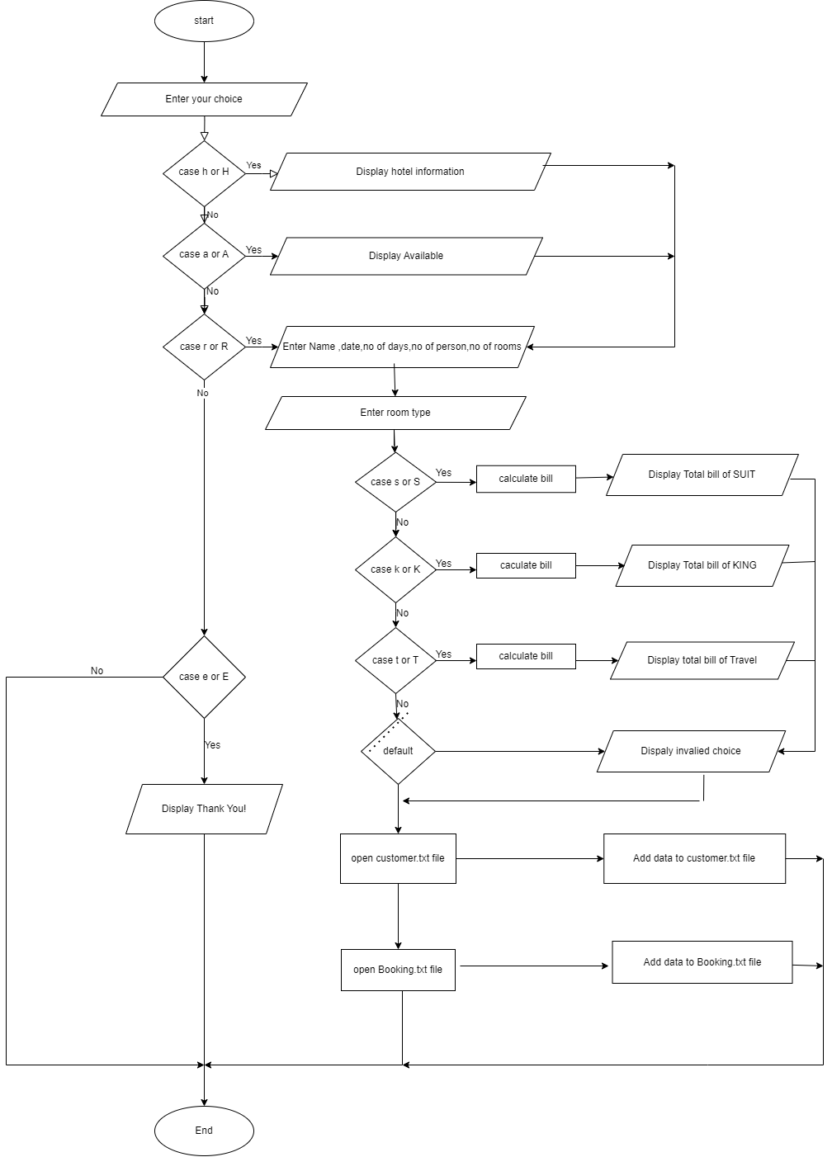

*BEGINE*

*ENTER your choice*

*CASE h OR H*

*DISPLAY hotel information*

*CASE a or A*

*DISPLAY Available*

*CASE r OR R*

*ENTER Name, date, no of days, no of person, no of rooms*

*ENTER room type*

*CASE s or S*

*Calculate bill*

*DISPLAY Total bill of SUIT*

*CASE k or K*

*Calculate bill*

*DISPLAY Total bill of KING*

*CASE r or T*

*Calculate bill*

*DISPLAY Total bill of Travel*

*DEFAUILT*

*DISPLAY invalid choice*

*Open customer file*

*Add data to customer file*

*Open Booking file*

*Add data to Booking file*

*CASE e or E*

*DISPLAY Thank you!*

*END.*

**Foods ()**

**TG/2021/1080**

**R.M.S.R.A.Rathnayake**

From the program I wrote, a user can add new dishes to the food menu and add their prices, and he has the ability to remove those food items and change their prices also, if a user wants to find a certain food, I have provided the necessary facilities.

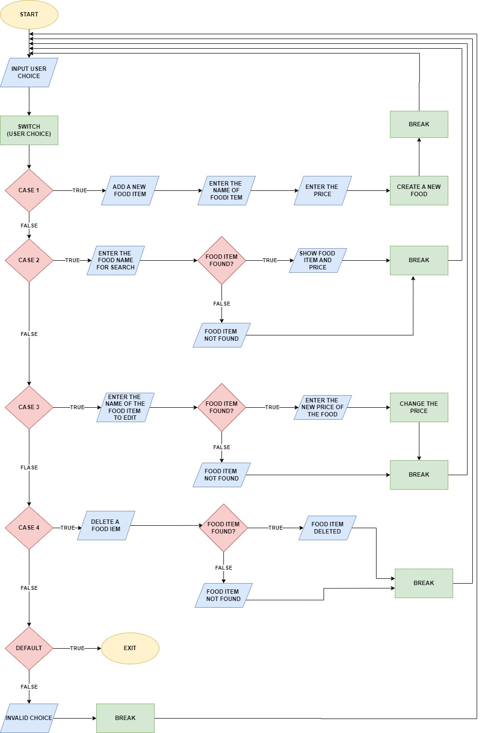

*BEGIN*

*Input user choice ;*

*Switch(user choice);*

*If case 1;*

*Then;*

*Add a new food item;*

*Enter the name of food item;*

*Create a new food;*

*Break;*

*Else if case 2;*

*Enter the food name for search;*

*If food item found?;*

*Then;*

*Show food item and price;*

*Break;*

*Else;*

*Food item not found;*

*Break;*

*End if;*

*Else if case 3;*

*Enter the name of the food item to edit;*

*If food item found?;*

*Then;*

*Enter the new price of the food;*

*Break;*

*Else;*

*Food item not found;*

*Break;*

*End if*

*Else if case 4;*

*Delete a food item;*

*If food item found?;*

*Then;*

*Food item deleted;*

*Break;*

*Else;*

*Food item not found;*

*Break;*

*End if;*

*Else;*

*If user select correct default;*

*Then;*

*Exiting;*

*Else;*

*Invalid choice;*

*Break;*

*End if;*

*End if;*

*END.*

**Rooms and Spa ()**

**TG/2021/1039**

**K.A.A.D.Jayarathna**

Enter the User name and password log in to the hotel room & spa data base. Then Press the first key “Room & Spa”. Enter the Customer address, Name, Phone Number, Nationality, Email, Period, & Arrival Date etc. After entering the data press “ESC” key. Then press the second key “Rooms Details” then all entered data is displayed. Show all the details of the customer. Press 3rd key,

So data can be removed as needed. After clicking the fourth button, the user can get required information. Finally press the fifth key “customer bill”. So customer can get relevant room by paying money.

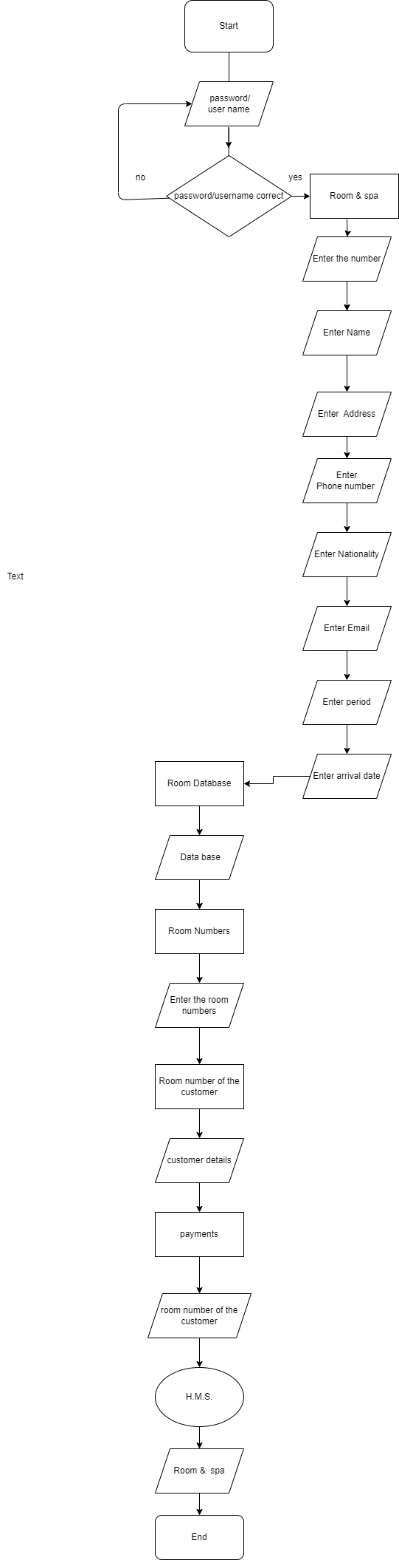

*Begin*

*FUNCTION add()*

*// add customer details*

*END FUNCTION*

*FUNCTION list()*

*// display all customer details*

*END FUNCTION*

*FUNCTION edit()*

*// edit customer details*

*END FUNCTION*

*FUNCTION delete1()*

*// delete customer details*

*END FUNCTION*

*FUNCTION search()*

*// search customer details*

*END FUNCTION*

*FUNCTION setcolor(int ForgC)*

*// set color of console output*

*END FUNCTION*

*FUNCTION login()*

*DECLARE a, i as INTEGER*

*DECLARE uname[10], pword[10], code[10], c as CHARACTER*

*DECLARE user[10], pass[10] as CHARACTER*

*vbnet*

*Copy code*

*SET a = 0*

*SET i = 0*

*SET user = "user"*

*SET pass = "pass"*

*LOOP WHILE a <= 2*

*CLEAR SCREEN*

*PRINT "************************** LOGIN FORM **************************"*

*PRINT "Enter username:"*

*GET uname*

*PRINT "Enter password:"*

*LOOP WHILE i < 10*

*SET c = GET CHARACTER*

*SET pword[i] = c*

*IF c = 13 THEN EXIT LOOP*

*ELSE PRINT "*"*

*END IF*

*SET i = i + 1*

*END LOOP*

*SET pword[i] = '\0'*

*SET i = 0*

*IF uname == user AND pword == pass THEN*

*PRINT "WELCOME !!!! LOGIN IS SUCCESSFUL"*

*BREAK LOOP*

*ELSE*

*PRINT "SORRY !!!! LOGIN IS UNSUCESSFUL"*

*SET a = a + 1*

*GET CHARACTER*

*END IF*

*END LOOP*

*IF a > 2 THEN*

*PRINT "Sorry you have entered the wrong username and password for four times!!!"*

*GET CHARACTER*

*END IF*

*CLEAR SCREEN*

*END FUNCTION*

*DECLARE s as CustomerDetails*

*DECLARE i as INTEGER*

*DECLARE t as TIME*

*CLEAR SCREEN*

*GET CURRENT TIME t*

*DISPLAY " -------------------------------------------------------------------------"*

*DISPLAY "| |"*

*DISPLAY "| |"*

*DISPLAY "| OOOOOO OOOOOO OOOOOO OOOOOO OOOOOO OOOOOO O O OOOOOOO OOOOOO |"*

*DISPLAY "| O O O O O O O O O O O O |"*

*DISPLAY "| O OOOOO OOOOOO OOOOO OOOOO O O O O O O OOOOO OOOOOO |"*

*DISPLAY "| O O O O O O O O O O O O O O |"*

*DISPLAY "| OOOOOO O O OOOOOO OOOOOO O OOOOOO O O O OOOOOO OOOOOO |"*

*DISPLAY "| |"*

*DISPLAY " -------------------------------------------------------------------------"*

*DISPLAY "\t\t*************************************************"*

*DISPLAY "\t\t* "*

*DISPLAY "\t\t ------------------------------------ "*

*DISPLAY "\t\t WELCOME TO HOTEL MANAGEMENT SYSTEM "*

*DISPLAY "\t\t ------------------------------------ "*

*DISPLAY "\t\t "*

*DISPLAY "\t\t "*

*DISPLAY "\t\t "*

*DISPLAY "\t\t "*

*DISPLAY "\t\t CONTACT US:071-12345678 "*

*DISPLAY "\t\t************************************************"*

*DISPLAY ""*

*FOR i = 0 TO 80*

*DISPLAY "-"*

*END FOR*

*DISPLAY "Current date and time :" + t*

*FOR i = 0 TO 80*

*DISPLAY "-"*

*END FOR*

*GET CHARACTER*

**Bar and Alcohol**

**TG/2021/1048**

**A.R.M.Geethanga**

Bar and alcohol store function allows users to view the available drinks and beverages which are in stock, place an order by providing relevant details, calculate the order price and confirm the orders shortly. The company will getting to save customer orders to a external file. And company have the able to manage customer orders by getting them into a single file. Additionally the function also includes input validations to ensure correct user inputs and provides a user friendly experience for ordering drinks from the bar and wine store.

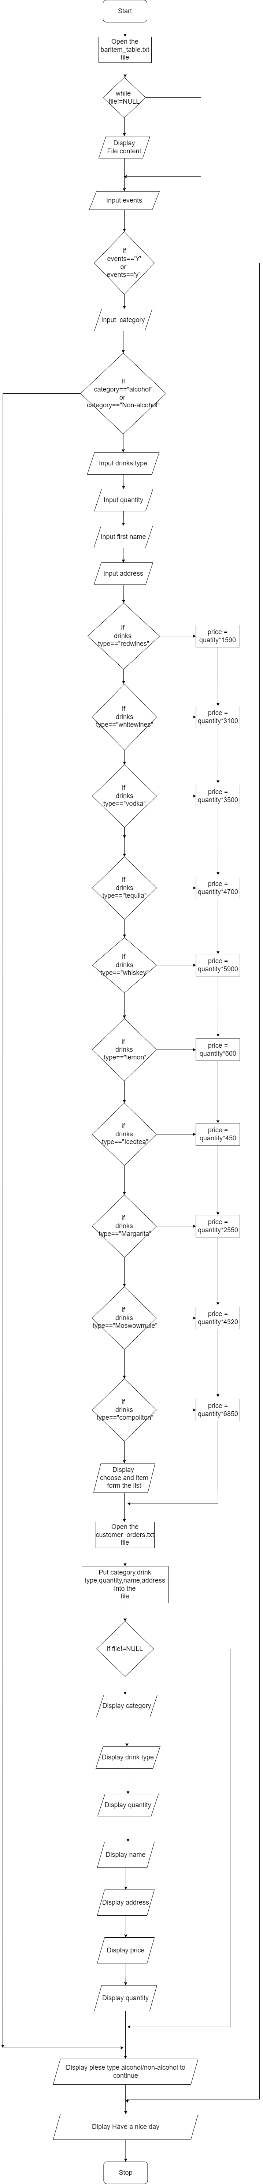

*BEGIN*

*OPENFILE baritem_table.txt file for read*

*WHILE (file != NULL)*

*OUTPUT file content*

*ENDWHILE*

*INPUT events*

*IF(events == ‘Y’) or (events ==’y’)*

*THEN*

*INPUT category*

*IF(category == “alcohol”) or (category == “Non-alcohol”)*

*THEN*

*INPUT drinks type*

*INPUT quantity*

*INPUT first name*

*INPUT address*

*IF(drinks type == “redwines”)*

*THEN*

*Price = quantity*1590*

*ELSE IF(drinks type == “whitewines”)*

*THEN*

*Price = quantity*3100*

*ELSE IF(drinks type == “vodka”)*

*THEN*

*Price = quantity*3500*

*ELSE IF(drinks type == “tequila”)*

*THEN*

*Price = quantity*4700*

*ELSE IF(drinks type == “whiskey”)*

*THEN*

*Price = quantity*5900*

*ELSE IF(drinks type == “lemon”)*

*THEN*

*Price = quantity*600*

*ELSE IF(drinks type == “icedtea”)*

*THEN*

*Price = quantity*450*

*ELSE IF(drinks type == “margarita”)*

*THEN*

*Price = quantity*2550*

*ELSE IF(drinks type == “moscowmule”)*

*THEN*

*Price = quantity*4320*

*ELSE IF(drinks type == “compoliton”)*

*THEN*

*Price = quantity*6850*

*ELSE*

*DISPLAY “choose an item from the list”*

*ENDIF*

*OPENFILE customer_orders.txt for write*

*WRITE category, drink type, quantity, name, address into the file*

*IF(file != NULL)*

*THEN*

*OUTPUT category*

*OUTPUT drink type*

*OUTPUT quantity*

*OUTPUT name*

*OUTPUT address*

*OUTPUT price*

*OUTPUT quantity*

*ELSE*

*DISPLAY “Please type alcohol/non-alcohol to continue”*

*ENDIF*

*ELSE*

*DISPLAY “Have a nice day”*

*ENDIF*

*END*

**Feedbacks and Complains**

**TG/2021/1081**

**M.D.V.Dias**

By using the Feedbacks function, the customer can use this function to input his opinion about the quality of the services in the system. A separate section can also be seen here for the opportunity to enter ideas and suggestions about new components and new facilities that can be included in the hotel and to submit complaints. Likewise, only hotel management or authorized users have been given the opportunity to view feedbacks and suggestions as well as complaints made by customers and to delete them if necessary.

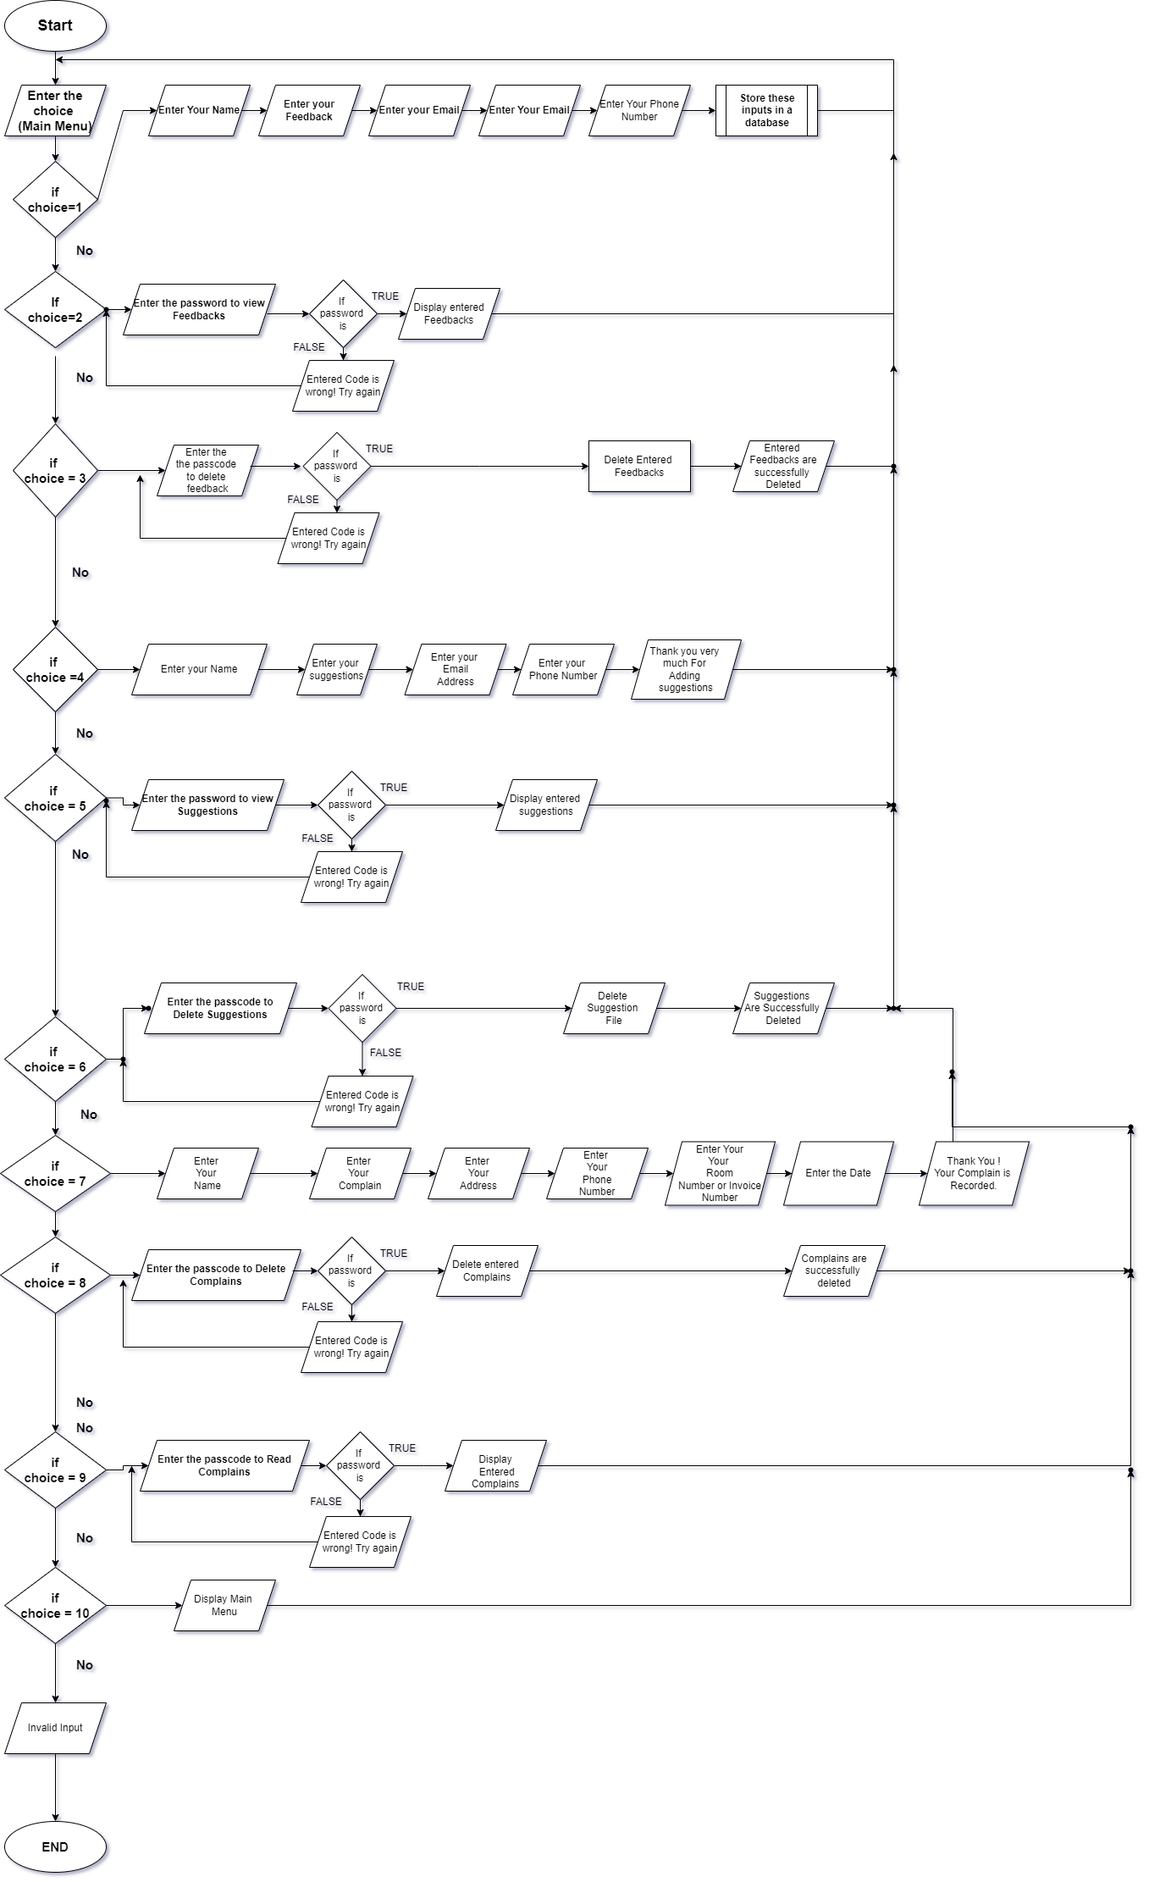

*Begin*

*Input choice*

*If Choice = 1*

*Then*

*Display Enter your Name*

*Display Enter your Feedback*

*Display Enter your Email*

*Display Enter Your Phone Number*

*Store these Inputs In a file*

*Else*

*If choice = 2*

*Then*

*Enter the System Password to view Feedbacks*

*If password is correct*

*Display Entered Feedbacks*

*Else*

*Display Error Message*

*End If*

*Else*

*If choice = 3*

*Then*

*Enter system Password to Delete Feedbacks*

*If password is correct*

*Delete Entered Feedbacks*

*Else*

*Display Error Message*

*End If*

*Else*

*If choice = 4*

*Then*

*Display Enter your Name*

*Display Enter your suggestion*

*Display Enter your Email Address*

*Display Enter your Phone Number*

*Else*

*If choice = 5*

*Then*

*Display Enter System Password to View Suggestion*

*IF Password is True*

*Then*

*Display Entered Suggestions*

*Else*

*Display*

*Entered Passcode is wrong please try again*

*End If*

*If choice = 6*

*Then*

*Display Enter passcode to delete suggestion*

*If passcode is true*

*Then*

*Delete Suggestion file*

*Display suggestions are successfully deleted*

*Else*

*Entered passcode is wrong please try again*

*End If*

*Else*

*If choice = 7*

*Then*

*Display Enter your name*

*Display Enter your complain*

*Display Enter your Address*

*Display Enter your Phone number*

*Display Enter your room number or invoice number*

*Display Enter the Date*

*Display Thank you. Your complain is successfully recorded.*

*Else*

*If choice = 8*

*Display enter the passcode to delete complains*

*If passcode is true*

*Then*

*Delete Entered complains*

*Display Entered complains are successfully deleted.*

*Else*

*Display Entered passcode is wrong. Please try again.*

*End if*

*Else*

*If choice = 9*

*Display Enter passcode to read complains*

*If Passcode is true*

*Display Entered Complains*

*Else*

*Display Entered passcode is wrong. Please try again.*

*End If*

*Else*

*If choice = 10*

*Display main menu*

*Else*

*Display Invalid Input*

*End if*

*End if*

*End if*

*End if*

*End if*

*End if*

*End if*

*End if*

*End if*

*End if*

1. **References**

[1] “c programming concepts and tutorials, [online]. Available: <https://w3schools.com/c>

[2] “c programming concepts and tutorials”, [online]. Available: <https://www.stackoverflow.com>

[3] “ c programming tutorial”,[online]. Available: <https://geeksforgeeks.org/c-programming-language/>.

[4] “c programming tutorial”, [online]. Available:

<https://tutorialspoint.com/cprogramming/>.

[5] Brian W.kernighan and Dennis M.Ritche*, C PROGRAMMING* *LANGUAGE*, 2nd edition, Pearson, 1988.

[6] Paul deitel and Harvey deital, *C how to program*, 8th edition, Pearson, 2015.

[7] “c programming tutorial”, [online]. Available: <https://freecodecamp.org/c-programming/>.

[8] “c programming tutorials and lessons”, [online]. Available:

<https://sololearn.com/c-programming/>.